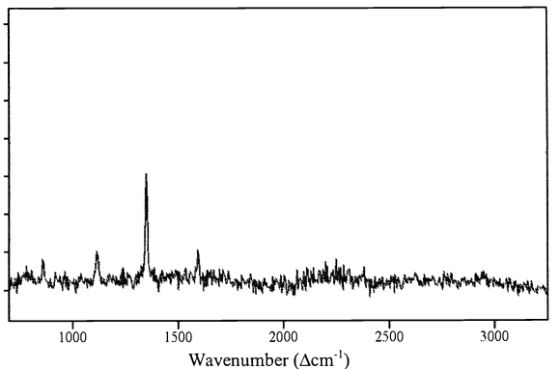

Figure 1: <https://doi.org/10.1117/12.418724>

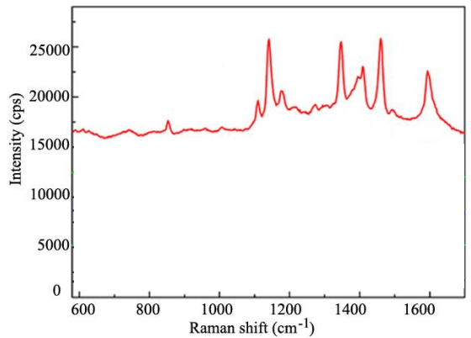

Figure 2: <https://doi.org/10.1021/acssensors.6b00312>

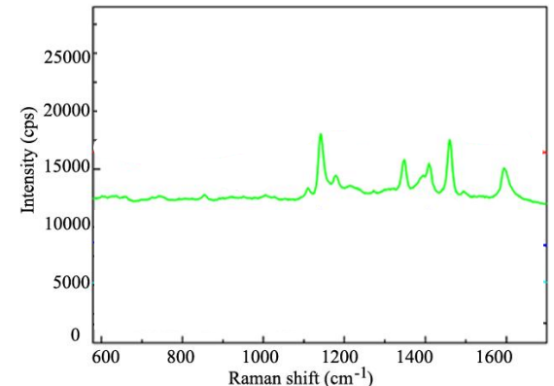

Figure 3: <https://doi.org/10.1021/acssensors.6b00312>

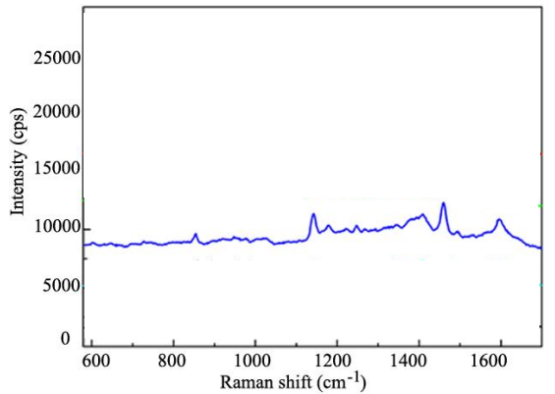

Figure 4: <https://doi.org/10.1021/acssensors.6b00312>

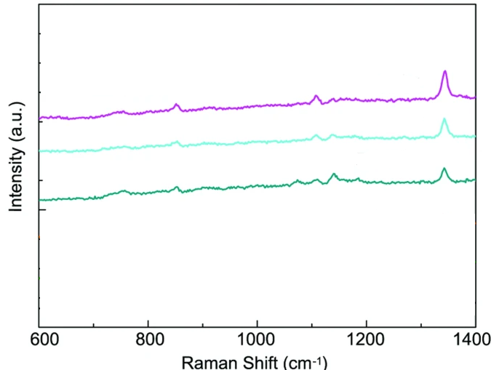

Figure 5: <https://doi.org/10.1038/srep12865>

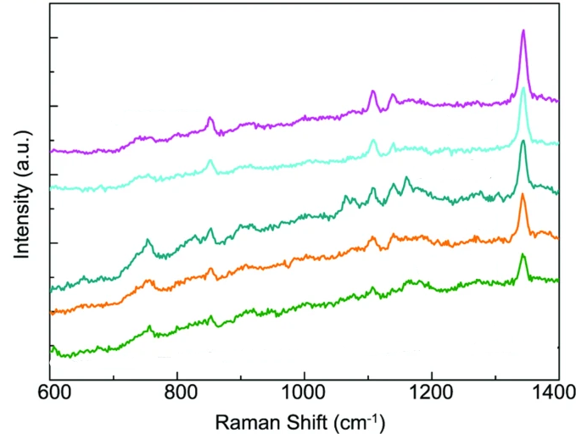

Figure 6: <https://doi.org/10.1038/srep12865>

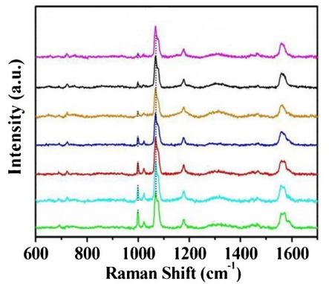

Figure 7: https://doi.org/10.1007/s00216-022-04400-0

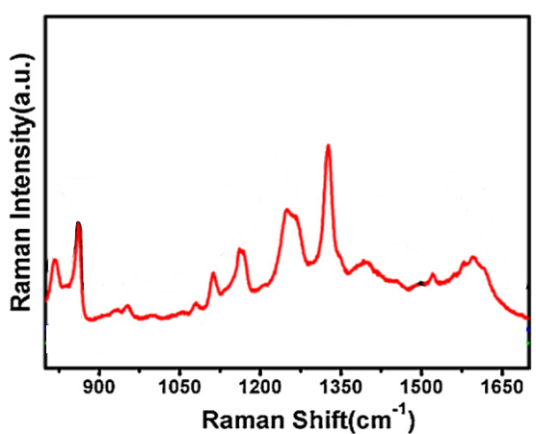

Figure 8: <https://doi.org/10.1016/j.apsusc.2013.01.014>

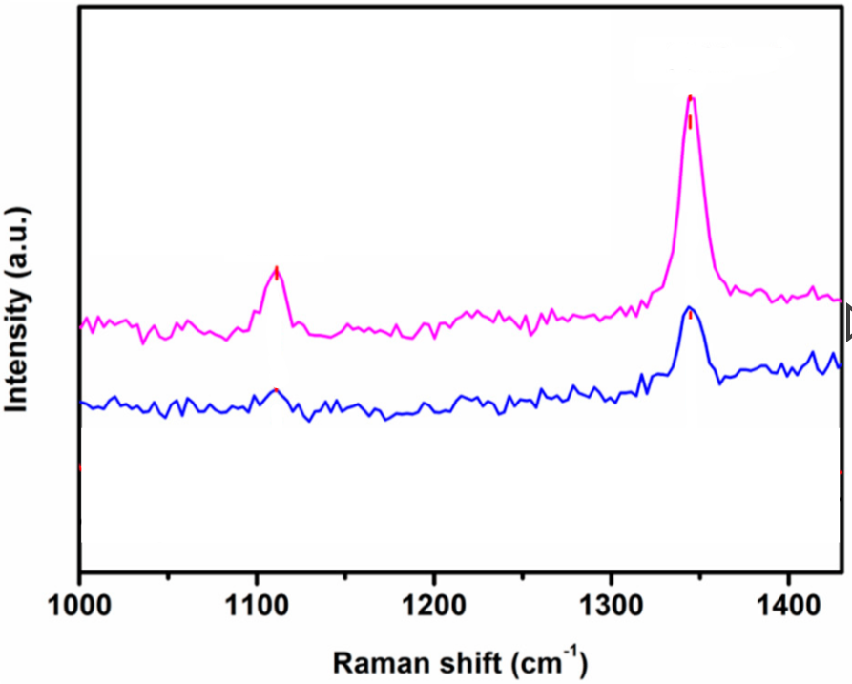

Figure 9: <https://doi.org/10.3390/s18092862>

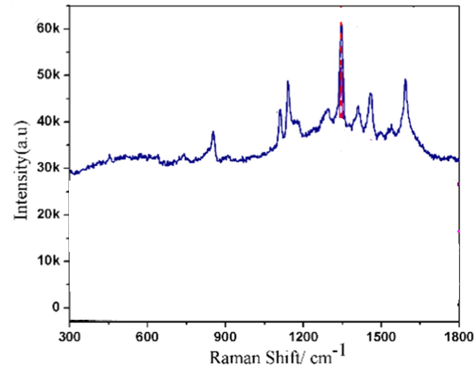

Figure 10: https://doi.org/10.1088/0957-4484/27/38/384001

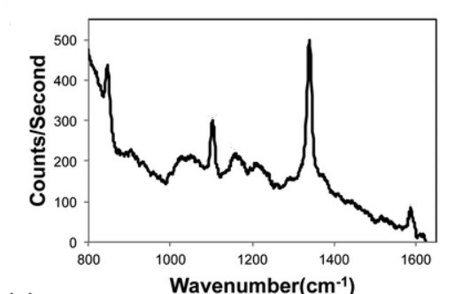

Figure 11: <https://doi.org/10.1039/C2AN36232E>

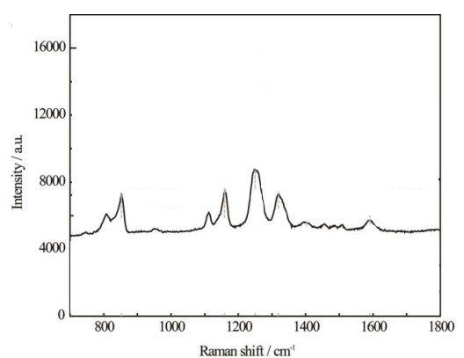

Figure 12: <https://doi.org/10.1039/C4NR03398A>

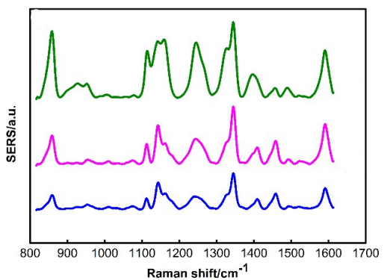

Figure 13: <https://doi.org/10.1039/C9AY01494B>

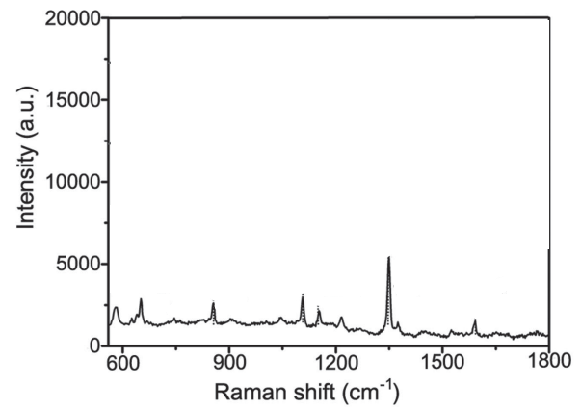

Figure 14: <https://doi.org/10.1002/smll.201501505>

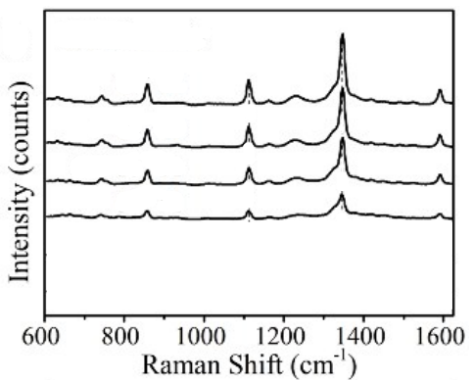

Figure 15: <https://doi.org/10.1039/C6TC04579K>

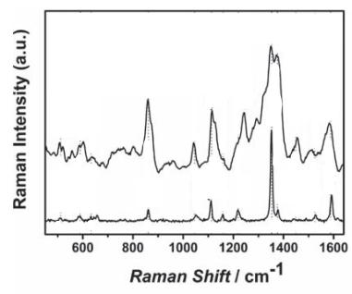

Figure 16: <https://doi.org/10.1002/adfm.201000792>

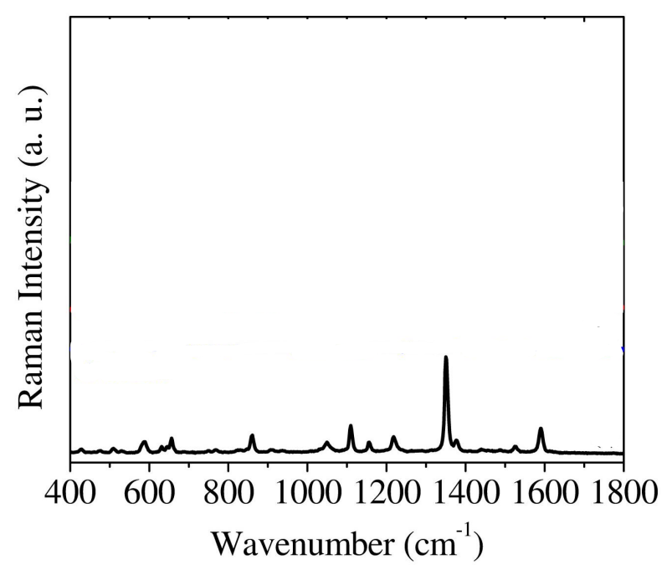

Figure 17: <https://doi.org/10.1016/j.snb.2016.11.006>

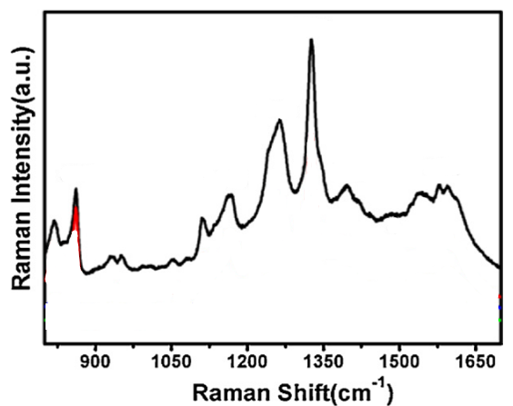

Figure 18: <https://doi.org/10.1016/j.apsusc.2013.01.014>

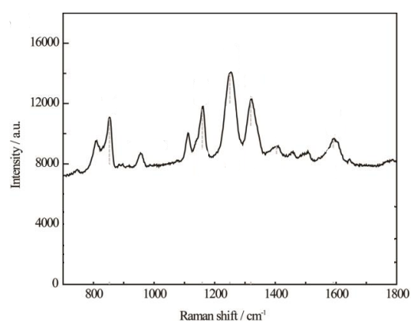

Figure 19: <https://doi.org/10.1039/C4NR03398A>

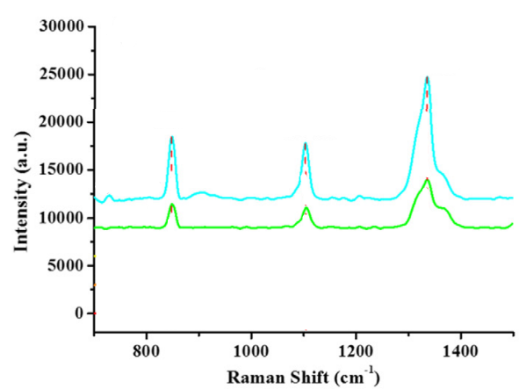Figure 20: https://doi.org/10.1016/j.saa.2020.118104

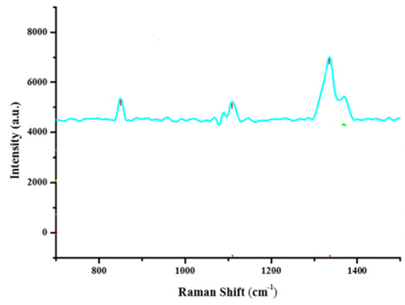

Figure 21: https://doi.org/10.1016/j.saa.2020.118104

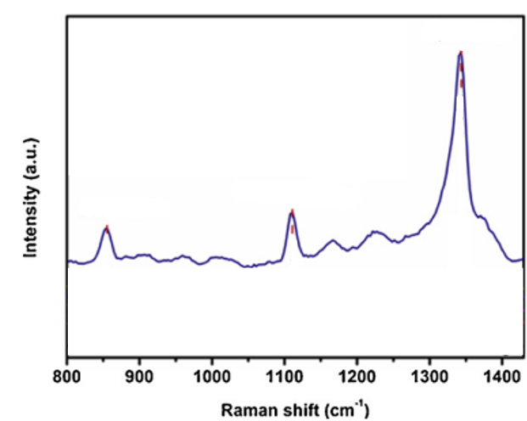

Figure 22: https://doi.org/10.1016/j.vibspec.2023.103586

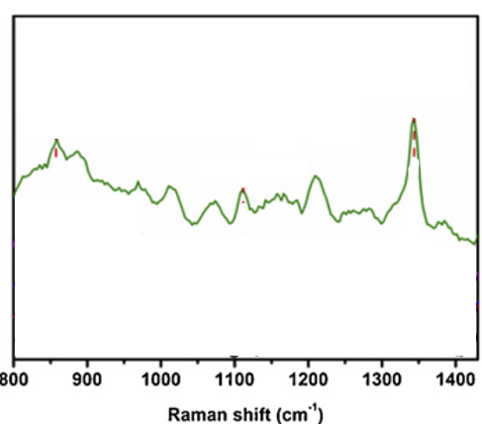

Figure 23: https://doi.org/10.1016/j.vibspec.2023.103586

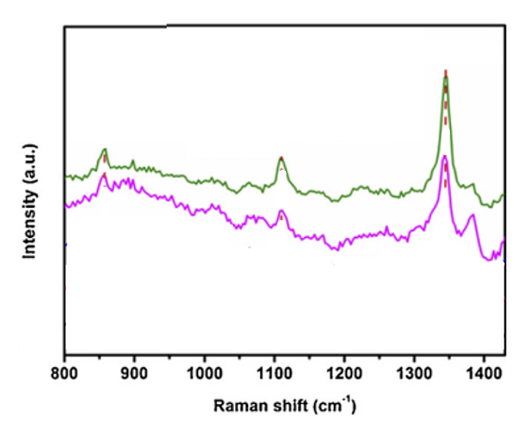

Figure 24: https://doi.org/10.1016/j.vibspec.2023.103586

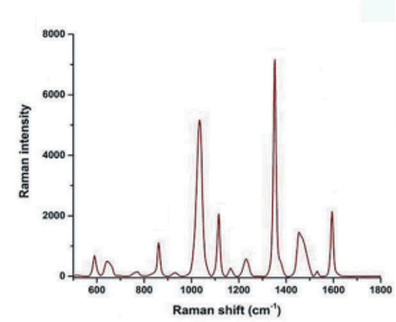

Figure 25: https://doi.org/10.1080/19440049.2019.1582806

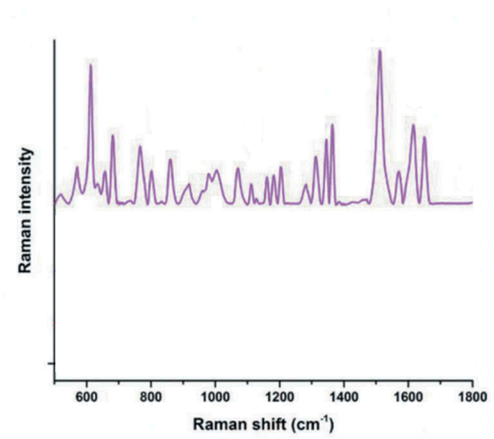

Figure 26: https://doi.org/10.1080/19440049.2019.1582806

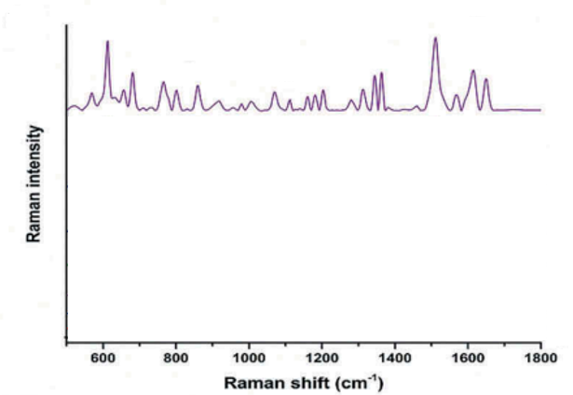

Figure 27: https://doi.org/10.1080/19440049.2019.1582806

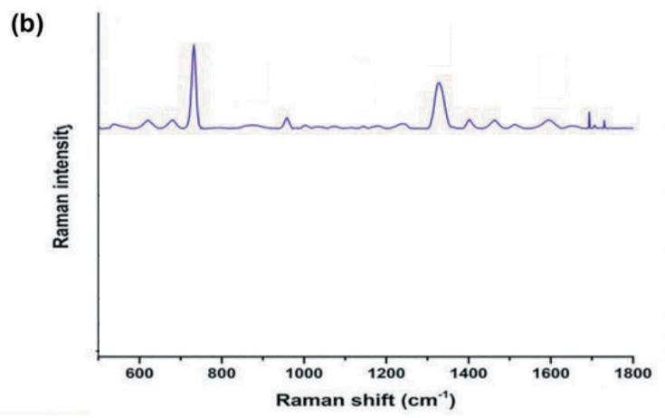

Figure 28: <https://doi.org/10.1080/19440049.2019.1582806>

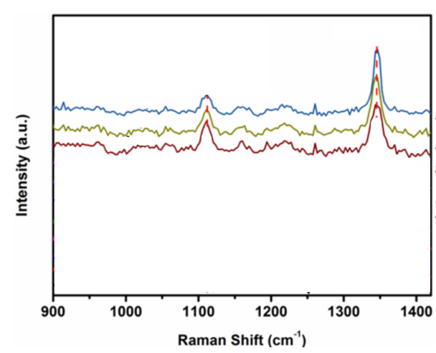

Figure 29: https://doi.org/10.1080/19440049.2019.1582806

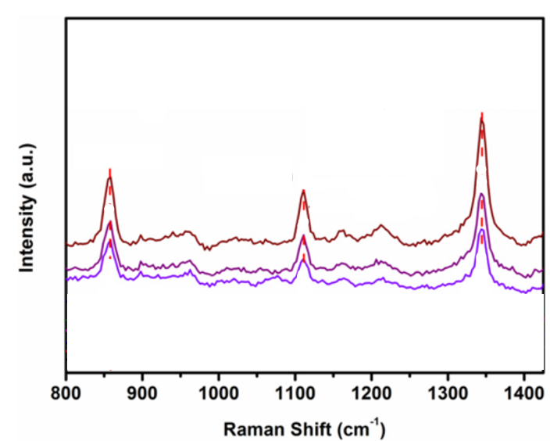

Figure 30: https://doi.org/10.1016/j.talanta.2019.03.004

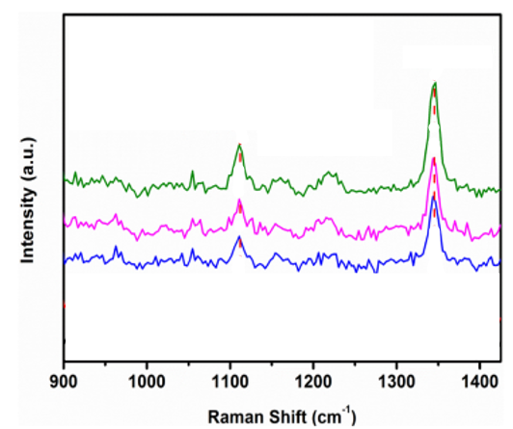

Figure 31: https://doi.org/10.1016/j.talanta.2019.03.004

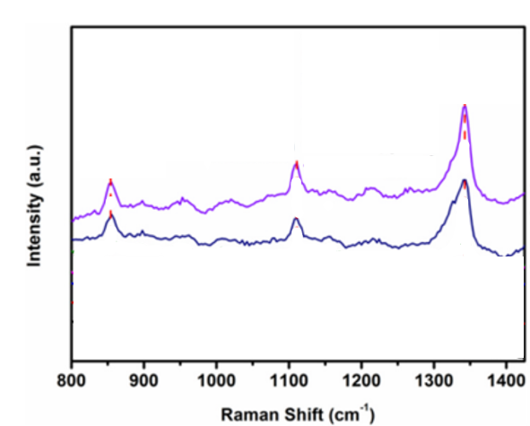

Figure 32: https://doi.org/10.1016/j.talanta.2019.03.004

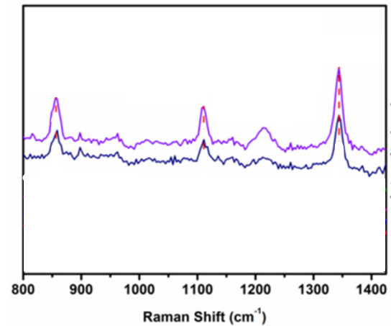

Figure 33: https://doi.org/10.1016/j.talanta.2019.03.004

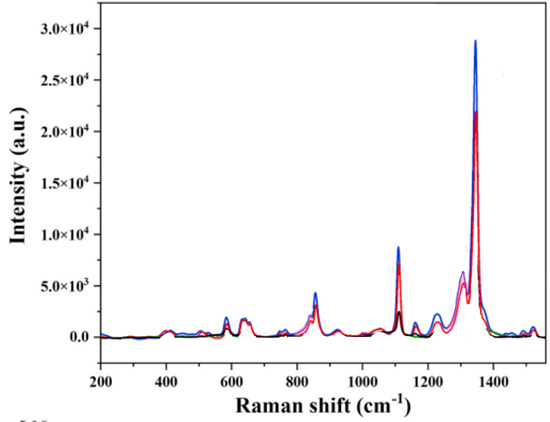

Figure 34: https://doi.org/10.1016/j.talanta.2019.03.004

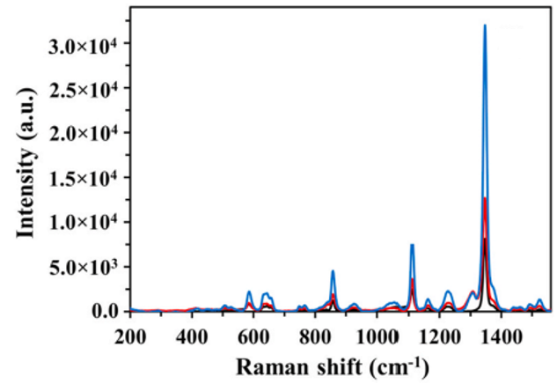

Figure 35: <https://doi.org/10.1016/j.chemosphere.2023.138081>

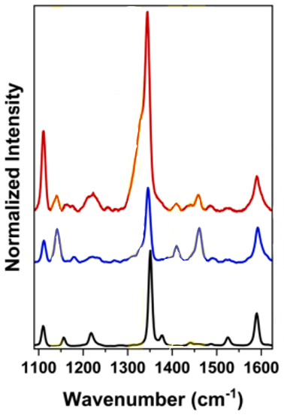

Figure 36: https://doi.org/10.1016/j.chemosphere.2023.138081

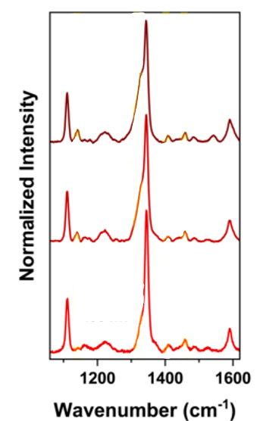

Figure 37: https://doi.org/10.1016/j.saa.2025.126422

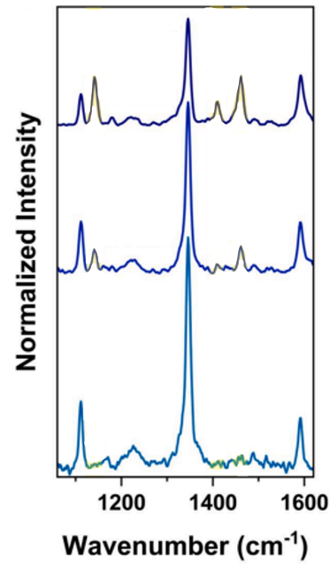

Figure 38: https://doi.org/10.1016/j.saa.2025.126422

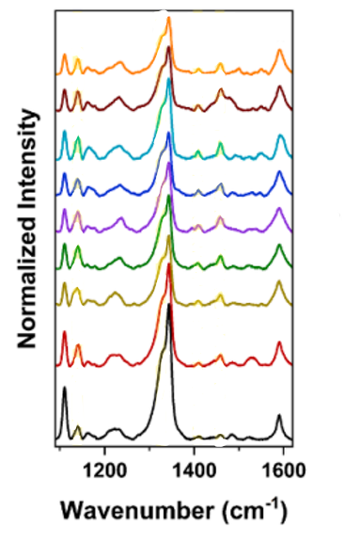

Figure 39: https://doi.org/10.1016/j.saa.2025.126422

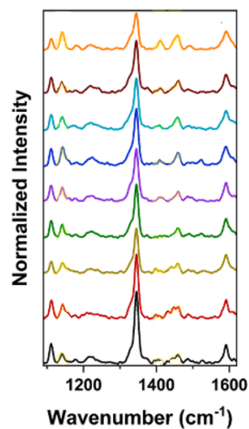

Figure 40: https://doi.org/10.1016/j.saa.2025.126422

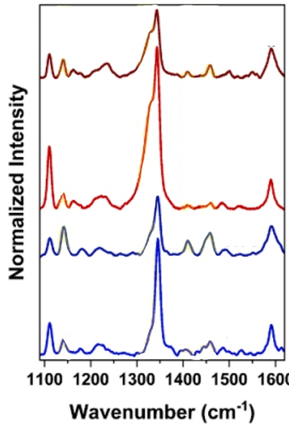

Figure 41: https://doi.org/10.1016/j.saa.2025.126422

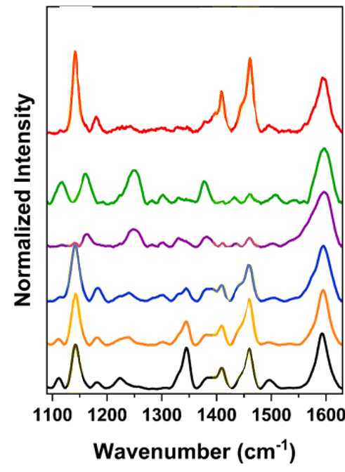

Figure 42: <https://doi.org/10.1016/j.saa.2025.126422>

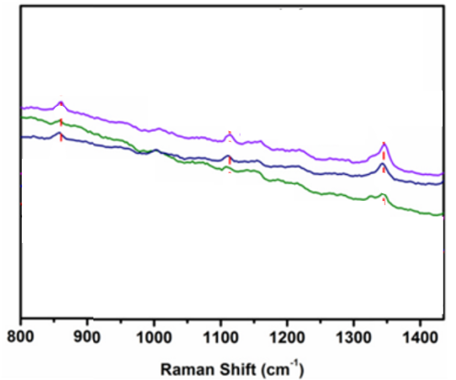

Figure 43: https://doi.org/10.1016/j.saa.2025.126422

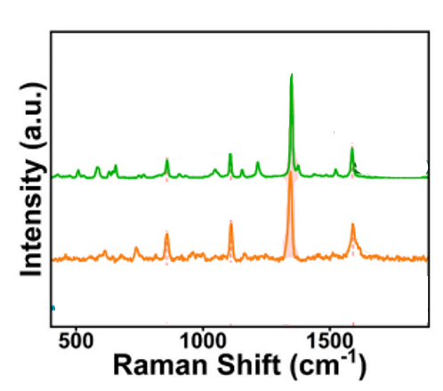

Figure 44: https://doi.org/10.1016/j.saa.2025.126422

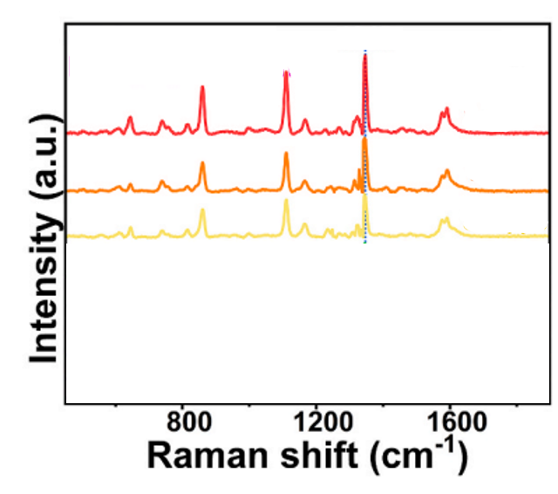

Figure 45: https://doi.org/10.1016/j.crfs.2025.101106

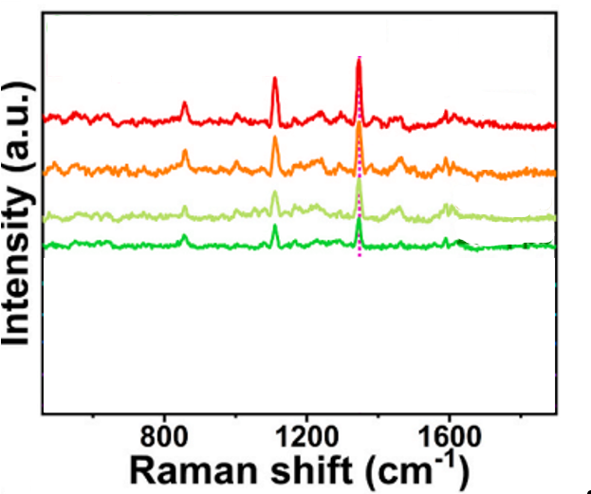

Figure 46: https://doi.org/10.1016/j.crfs.2025.101106

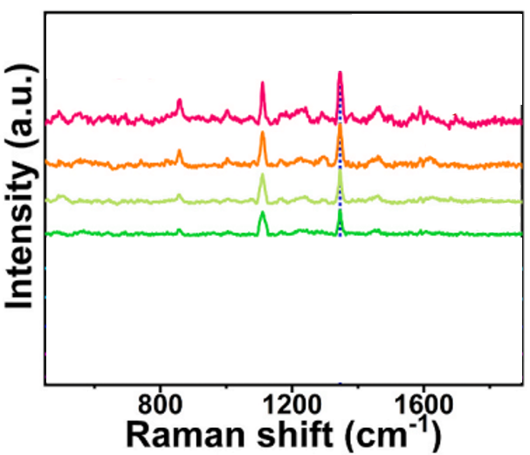

Figure 47: <https://doi.org/10.1016/j.crfs.2025.101106>

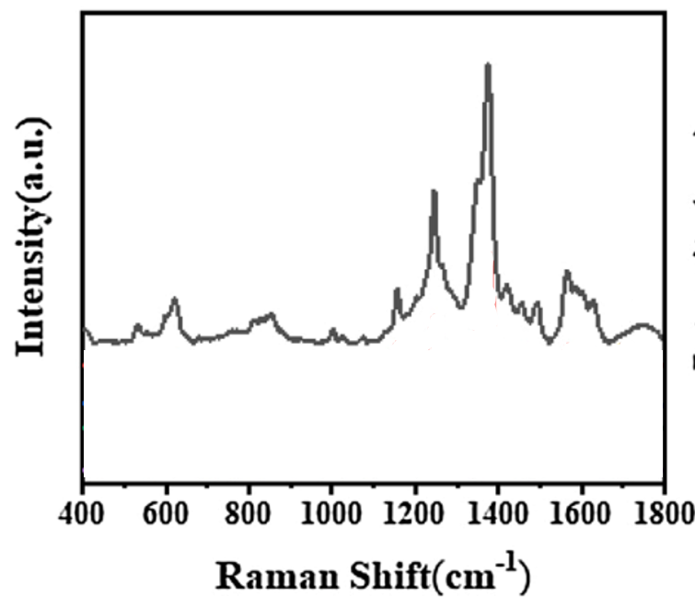

Figure 48: https://doi.org/10.1016/j.snb.2021.129909

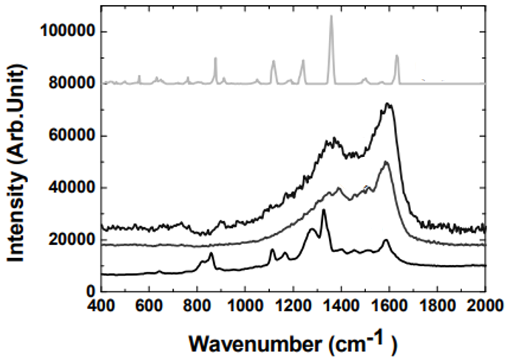

Figure 49: https://www.gpglobalize.in/images/pdf/CHEM%20VOL%20_%201&2.pdf#page=88

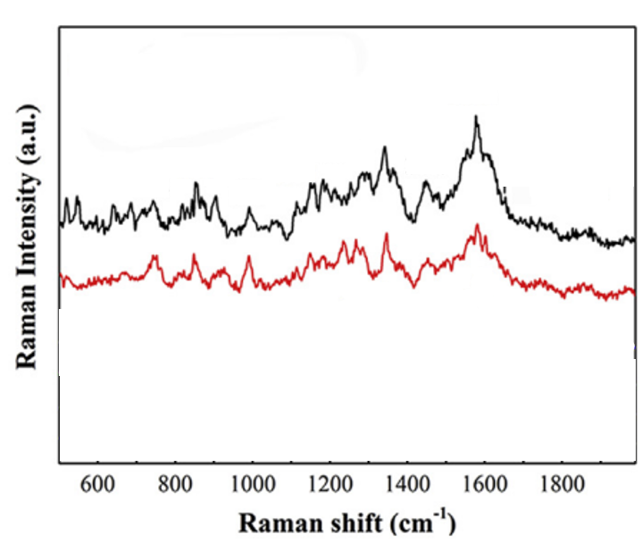

Figure 50: https://doi.org/10.1016/j.foodcont.2019.106835

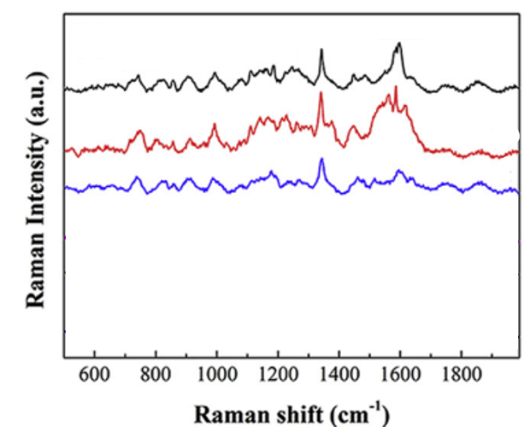

Figure 51: https://doi.org/10.1016/j.foodcont.2019.106835

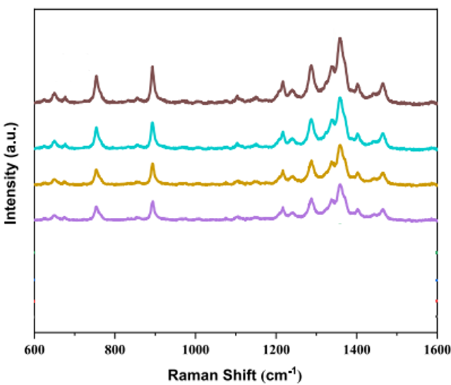

Figure 52: https://doi.org/10.1016/j.ijbiomac.2024.137171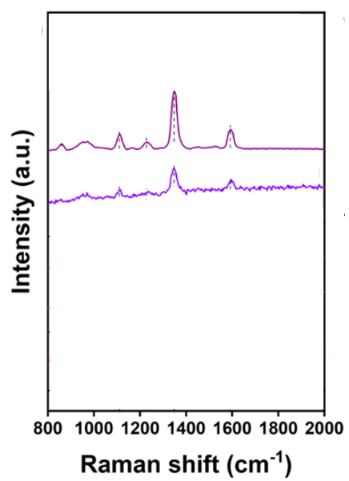

Figure 53: https://doi.org/10.3390/coatings12040506

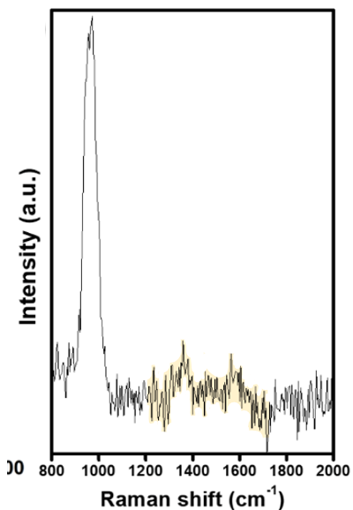

Figure 54: <https://doi.org/10.3390/coatings12040506>

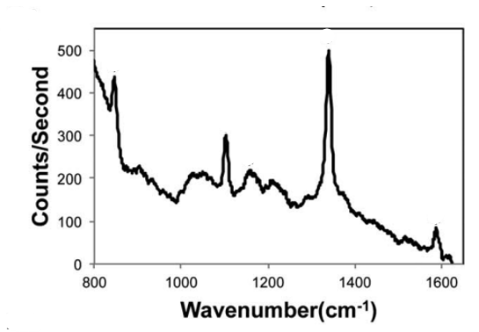

Figure 55: https://doi.org/10.1039/C2AN36232E

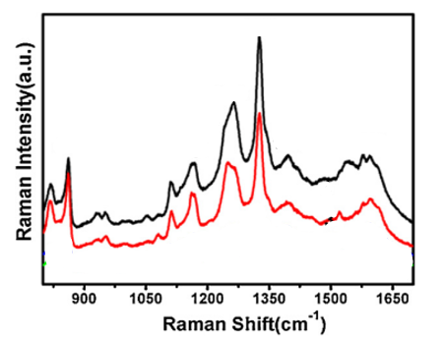

Figure 56: https://doi.org/10.1016/j.apsusc.2013.01.014

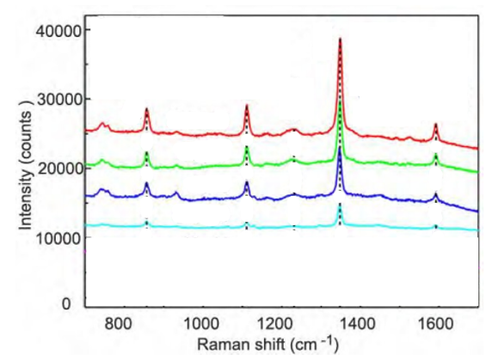

Figure 57: <https://doi.org/10.1039/C6AN00807K>

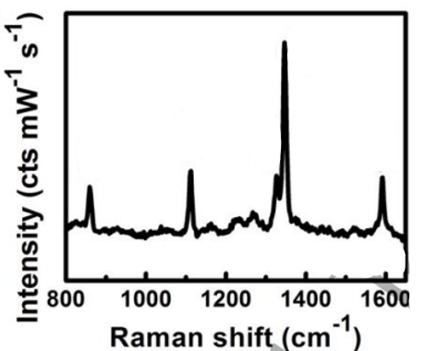

Figure 58: :DOI 10.1088/1361-6528/ab7100

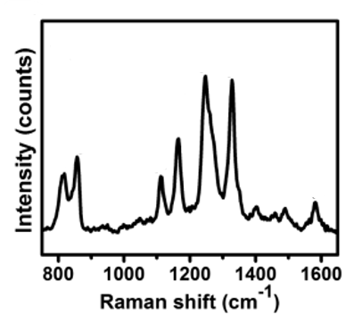

Figure 59: https://doi.org/10.1016/j.apsusc.2018.11.169

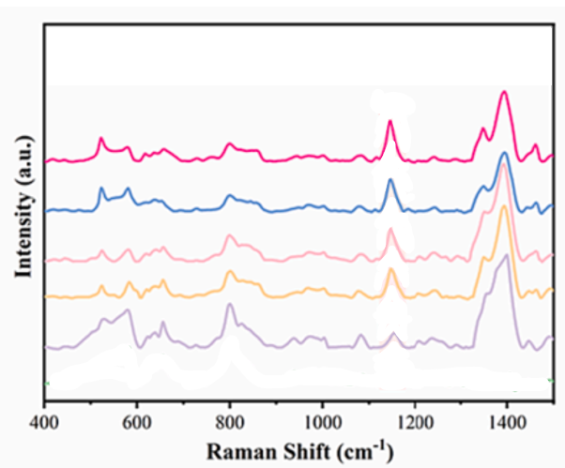

Figure 60: https://doi.org/10.1016/j.foodchem.2024.138846

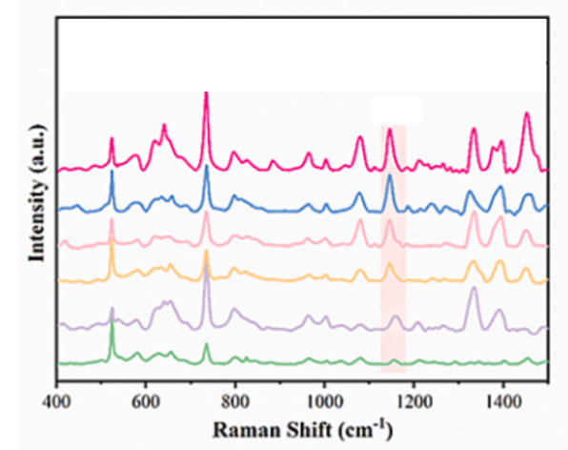

Figure 61: <https://doi.org/10.1016/j.foodchem.2024.138846>

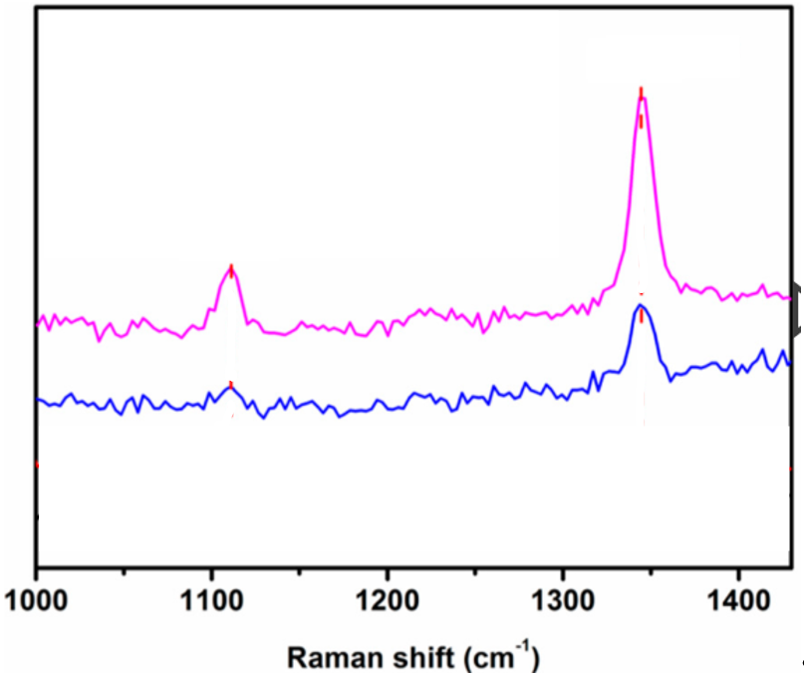Figure 62: https://doi.org/10.3390/s18092862

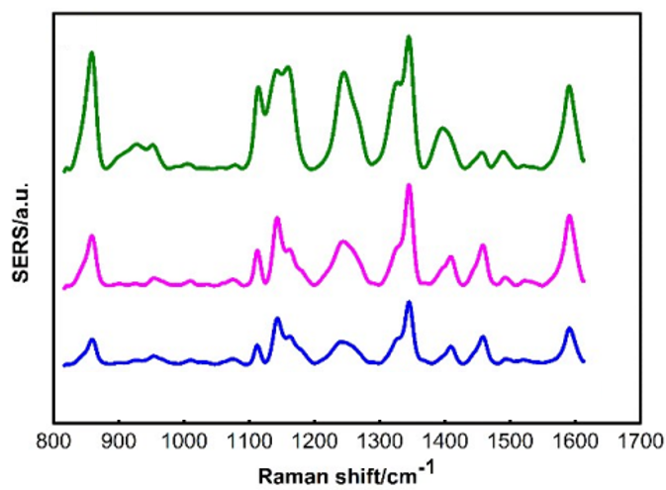

Figure 63: https://doi.org/10.1039/C9AY01494B

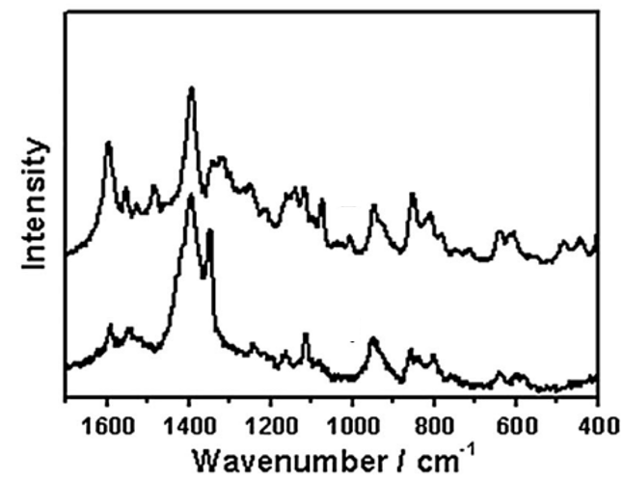Figure 64: https://doi.org/10.1002/jrs.4137

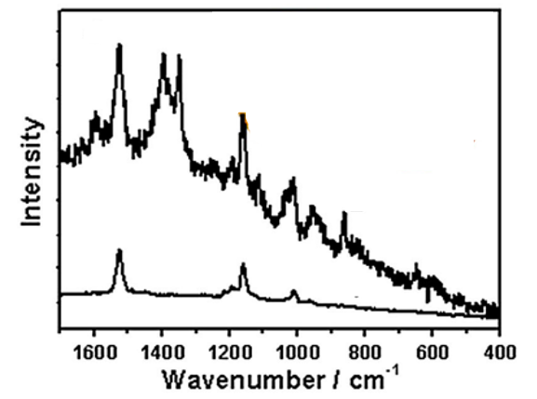

Figure 65: https://doi.org/10.1002/jrs.4137

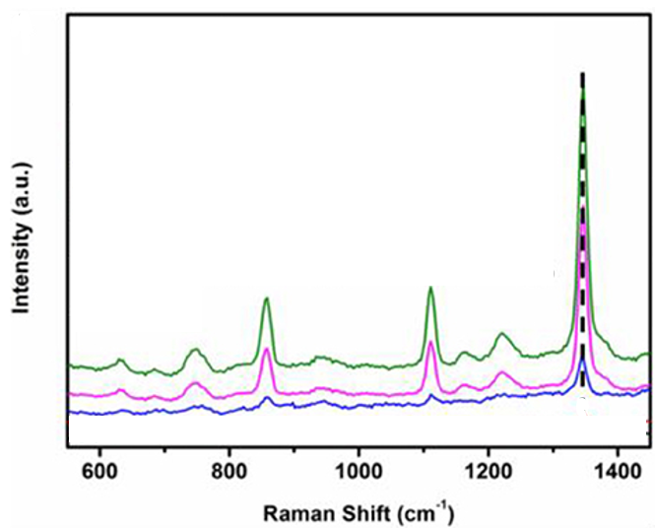Figure 66: https://doi.org/10.3389/fchem.2018.00482

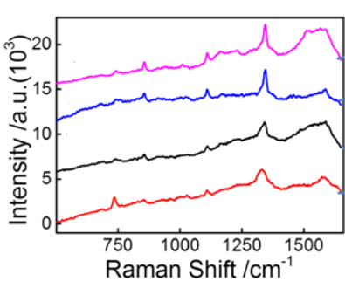

Figure 67: https://doi.org/10.1021/acs.analchem.5b03735

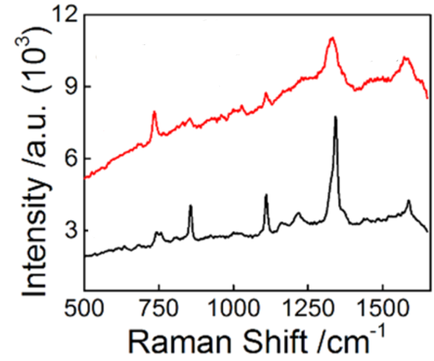

Figure 68: <https://doi.org/10.1021/acs.analchem.5b03735>

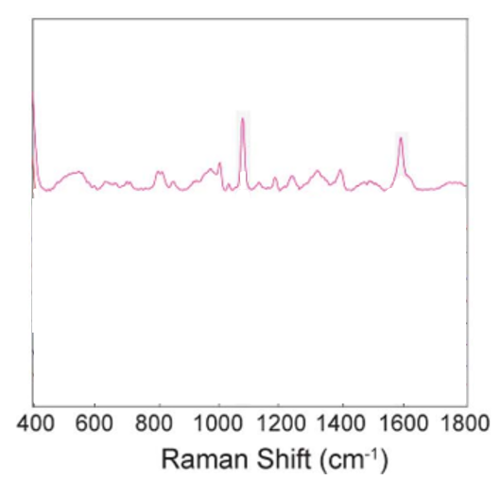

Figure 69: <https://doi.org/10.1039/C8AY01698D>

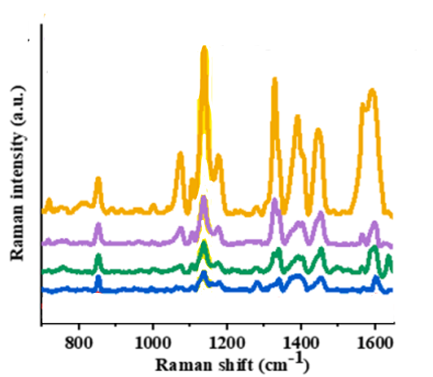

Figure 70: :https://doi.org/10.1016/j.saa.2023.122548

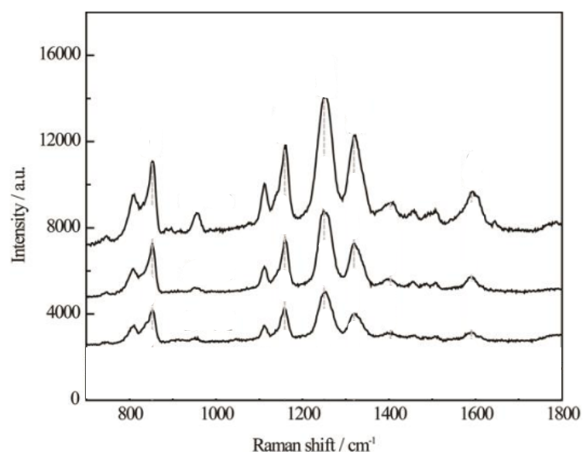

Figure 71: <https://doi.org/10.1039/C4NR03398A>

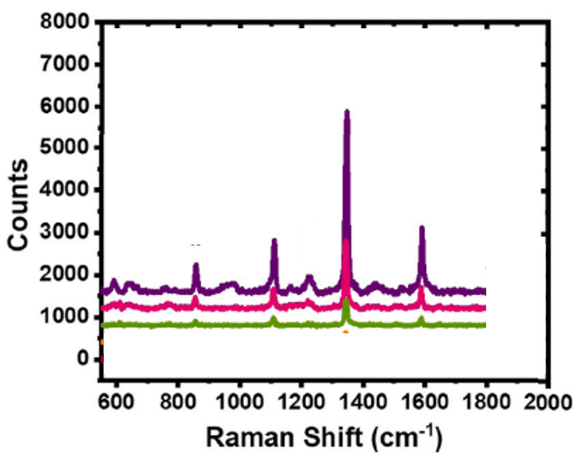

Figure 72: https://doi.org/10.1016/j.surfin.2022.102223

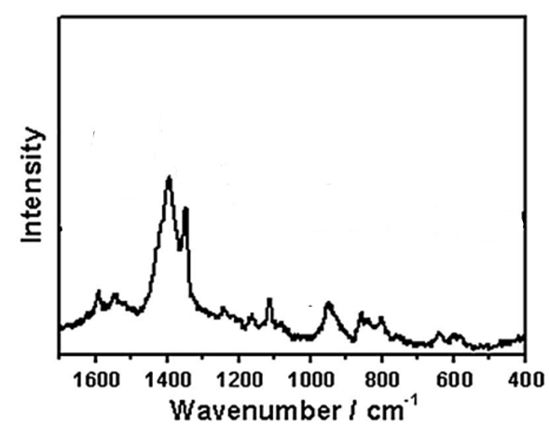

Figure 73: https://doi.org/10.1002/jrs.4137

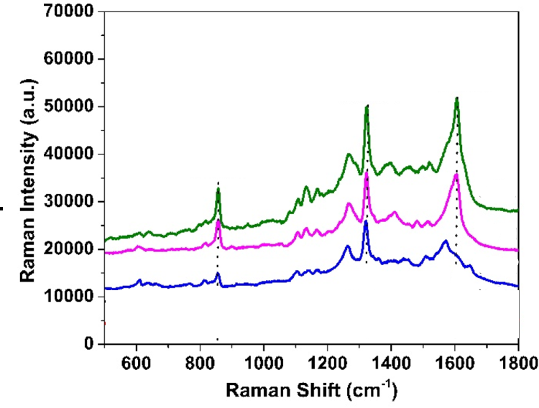

Figure 74: <https://doi.org/10.3390/nano15131007>

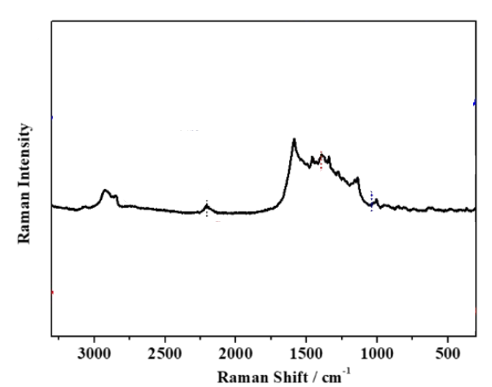

Figure 75: <https://doi.org/10.1039/C9AN01123D>

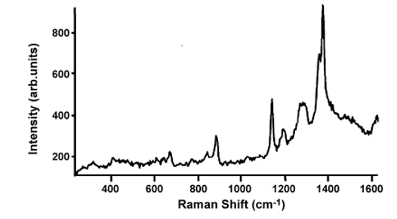

Figure 76: https://doi.org/10.1016/j.snb.2006.09.032

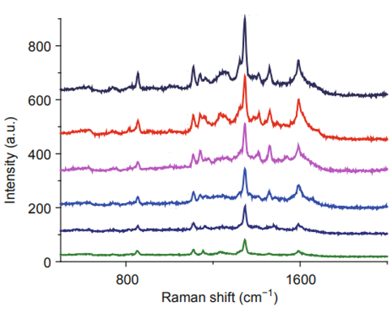

Figure 77: doi: 10.1007/s40843-015-0032-7

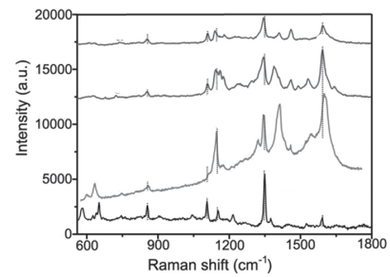

Figure 78: https://doi.org/10.1002/smll.201501505

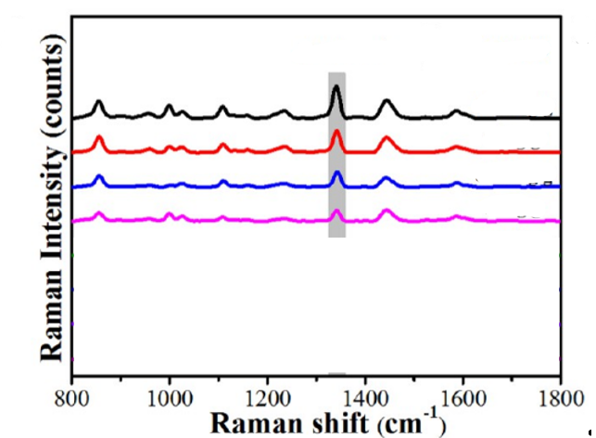

Figure 79: https://doi.org/10.1021/acsami.0c17471

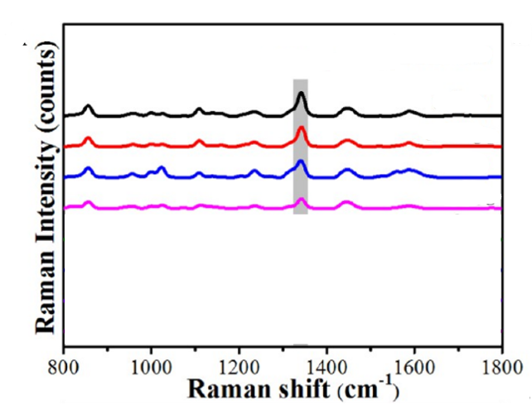

Figure 80: <https://doi.org/10.1021/acsami.0c17471>

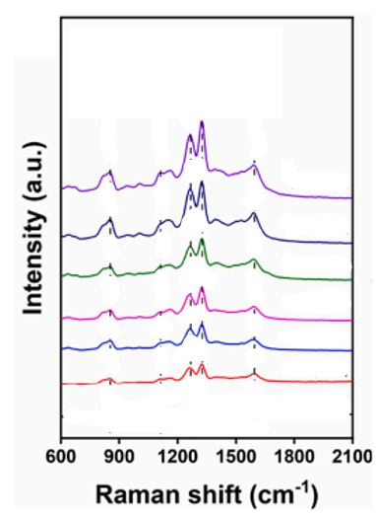

Figure 81: https://doi.org/10.1016/j.jiec.2025.04.010

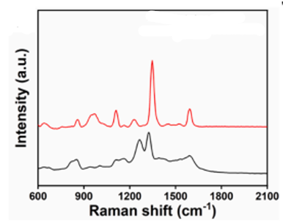Figure 82: <https://doi.org/10.1016/j.jiec.2025.04.010>

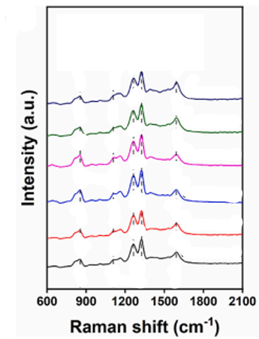

Figure 83: <https://doi.org/10.1016/j.jiec.2025.04.010>

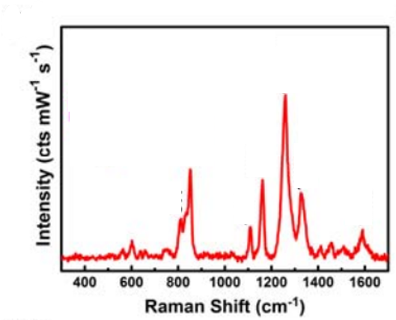Figure 84: DOI: 10.1002/adma.((please add manuscript number))

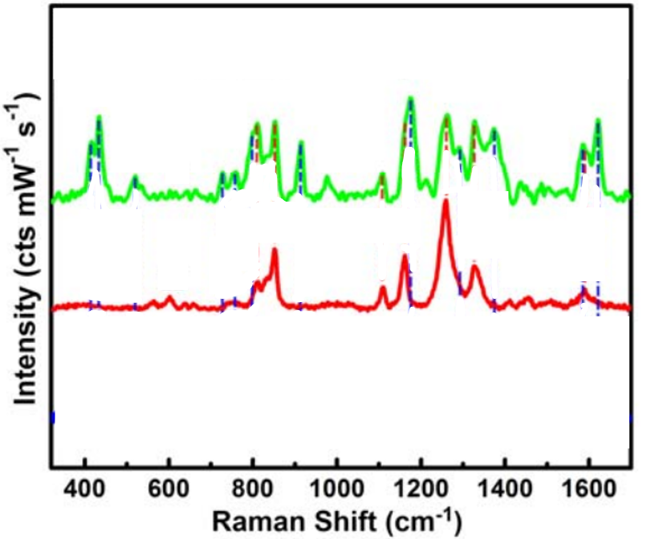

Figure 85: DOI: 10.1002/adma.((please add manuscript number))

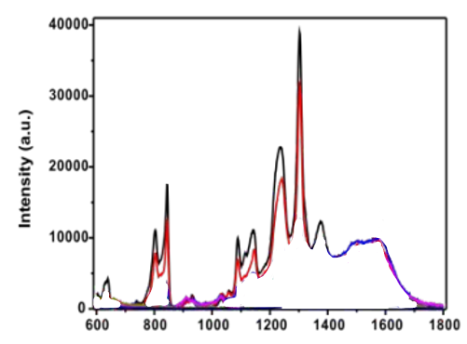

Figure 86: <https://doi.org/10.1039/C4AY03067B>

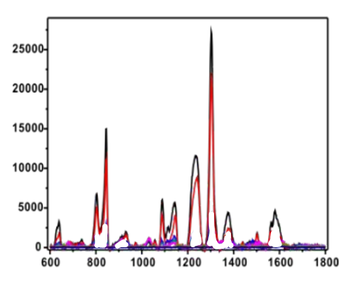

Figure 87: https://doi.org/10.1039/C4AY03067B

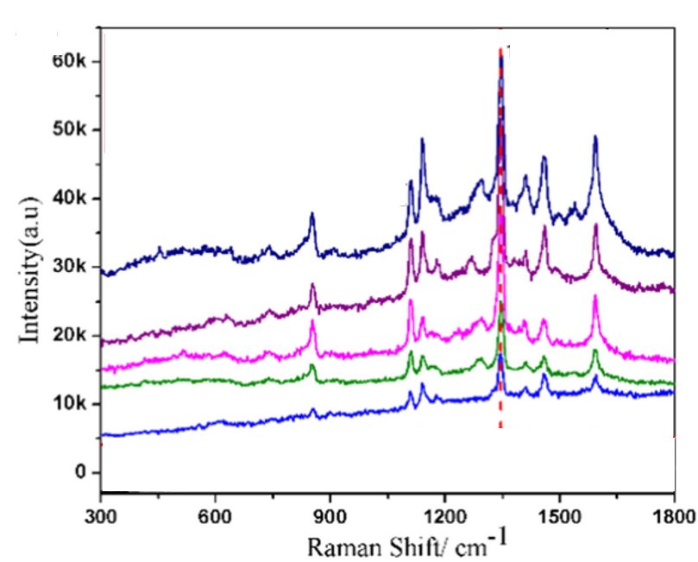

Figure 88: DOI 10.1088/0957-4484/27/38/384001

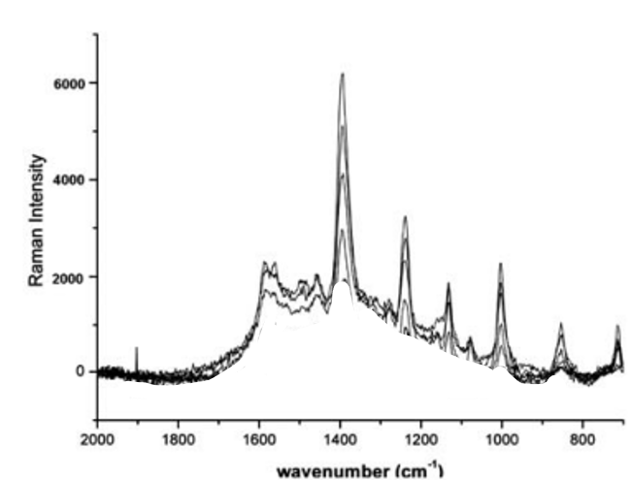

Figure 89: <https://doi.org/10.1039/C0JM00040J>

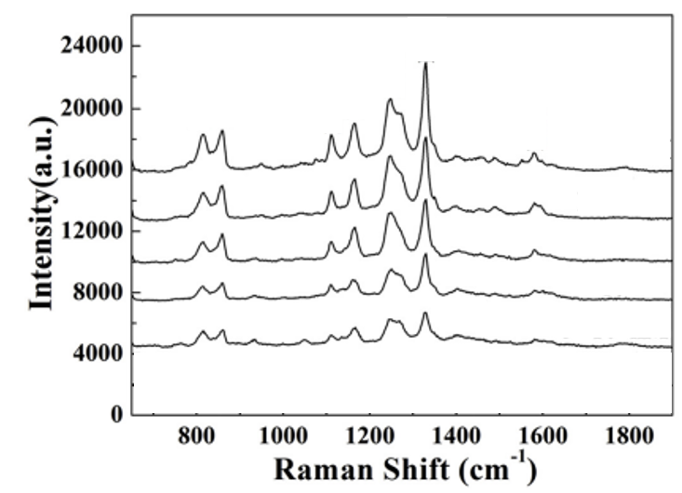

Figure 90: https://doi.org/10.1016/j.apsusc.2019.05.008

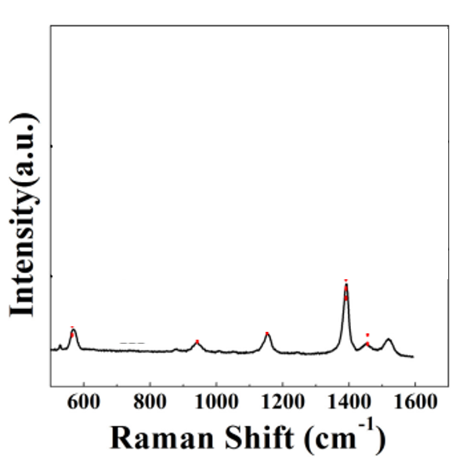

Figure 91: <https://doi.org/10.1016/j.apsusc.2019.05.008>

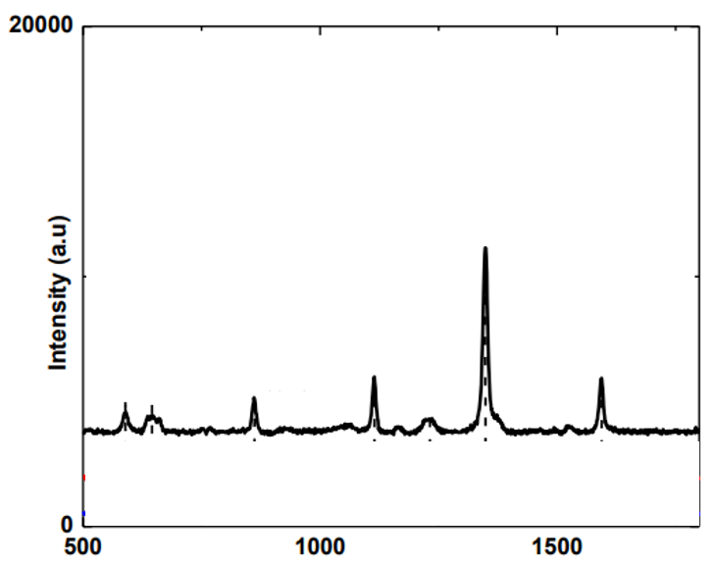Figure 92: DOI 10.1088/1742-6596/1428/1/012035

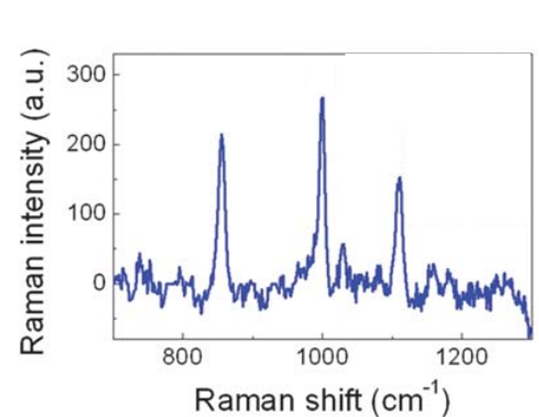

Figure 93: <https://doi.org/10.1039/C3TC30110A>

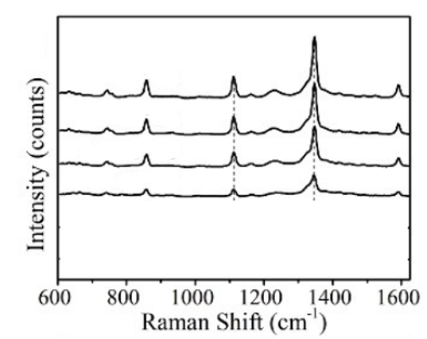

Figure 94: <https://doi.org/10.1039/C6TC04579K>

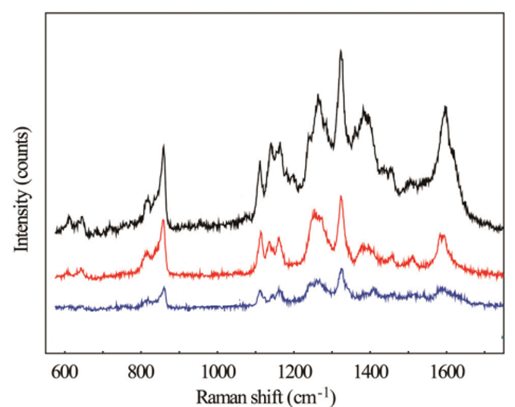

Figure 95: <https://doi.org/10.1039/C5NR06001J>

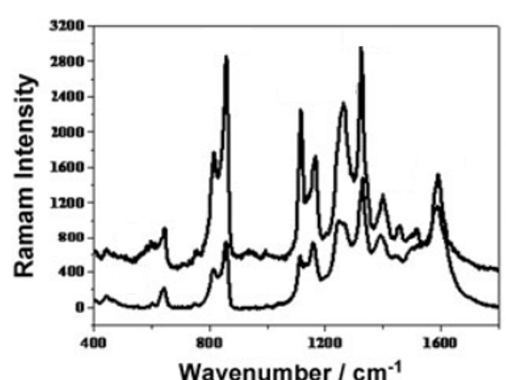

Figure 96: <https://doi.org/10.1002/jrs.3106>

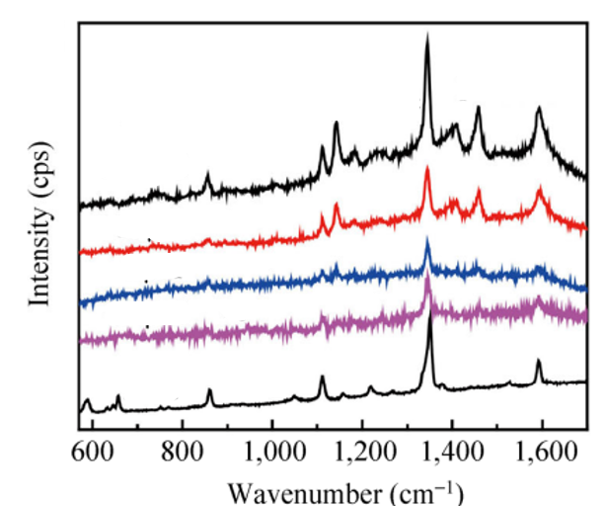

Figure 97: :https://doi.org/10.1007/s12274-014-0480-5

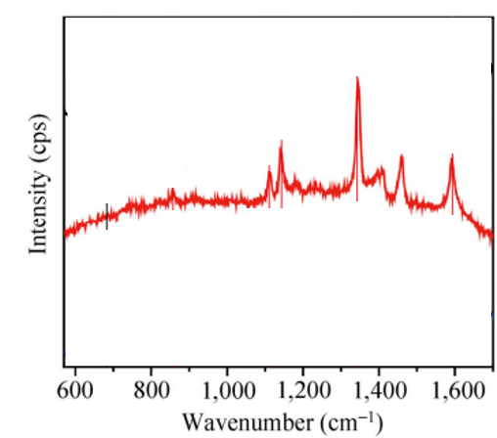

Figure 98: <https://doi.org/10.1007/s12274-014-0480-5>

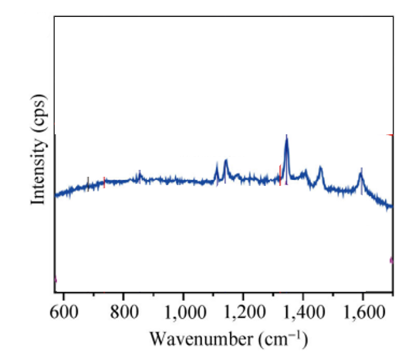

Figure 99: <https://doi.org/10.1007/s12274-014-0480-5>

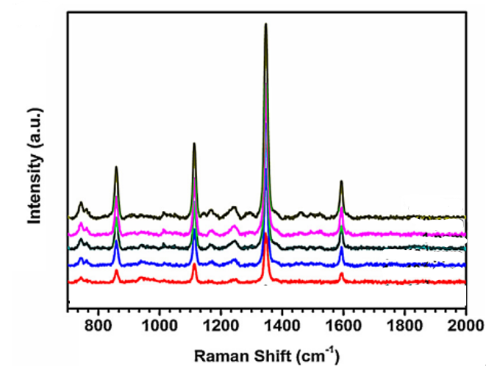

Figure 100: :https://doi.org/10.1016/j.apsusc.2016.03.225

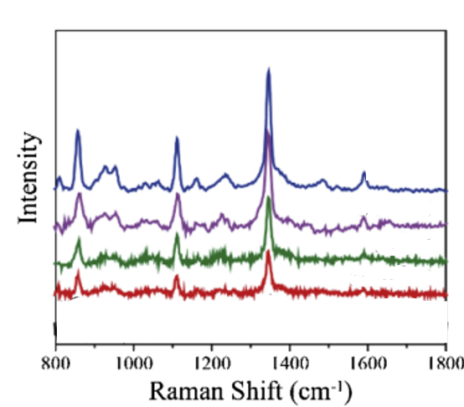

Figure 101: https://doi.org/10.1016/j.snb.2019.126990

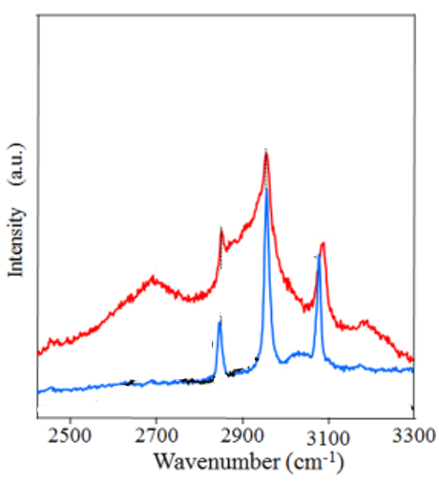

Figure 102: <https://doi.org/10.1021/acsanm.9b00007>

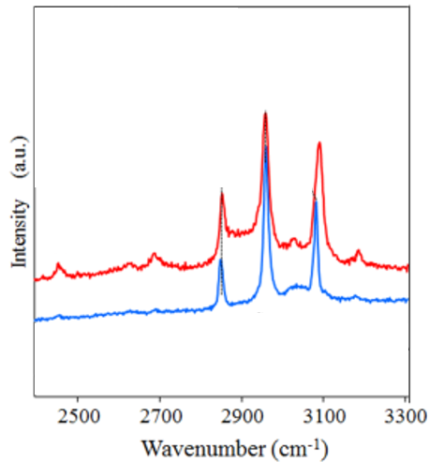

Figure 103: <https://doi.org/10.1021/acsanm.9b00007>

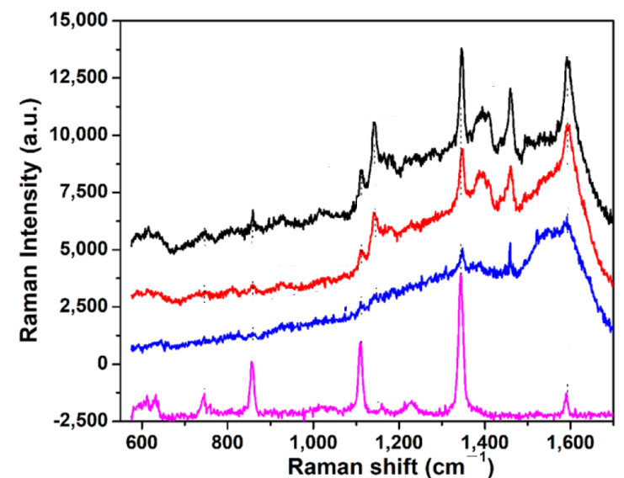

Figure 104: <https://doi.org/10.3390/su14031305>